# Key Points in C#

1. If you want to console a whole array, you don’t need to run a for loop. In fact, you can print a string of that array by *String.Join(“”, array) method.*
2. Question: program to find the first non-repeating character in a string.

In this I make a nested loop in [i] and check when word[i] == word[j]

1. C# mein method access krnay ka yay bhi tareeqa ha k *Datatype.*
2. int.MinValue , int.MaxValue
3. Array.Clear(arrayName, 3, 9)
4. Array.IndexOf(arrayName,elementName)

Array.IndexOf(arrayName,elementName, 2) //Iss index say aagay wo search krna start karay gaa

Array.IndexOf(arrayName,elementName, 2,3) // 2 index say 3 index tak karay gaa

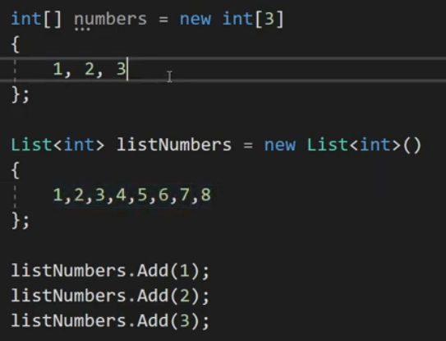

1. Arrays have .Length and List have .Count
2. Nested Loop mein 2 for each loop bhi chal sktay hein, Intersection walay problem ki trah:-  
   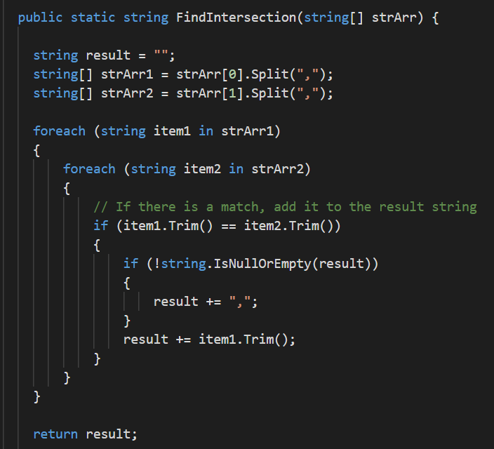
3. See this code, max length string find krny thy, to half number kr kay divisor check kiya aur wahaan tak decremental iterate kiya

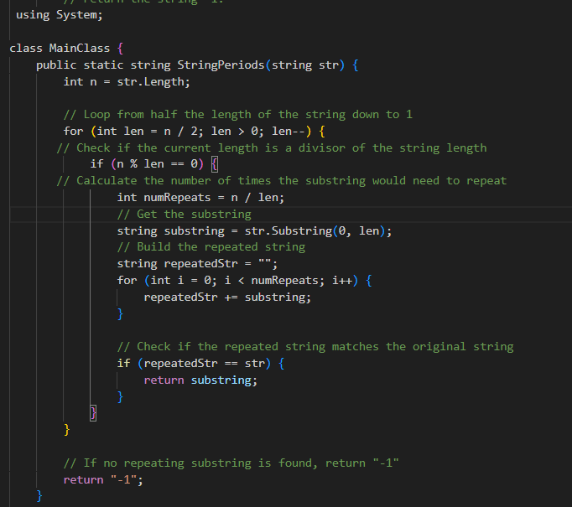

1. Regex ka use